Architecture:

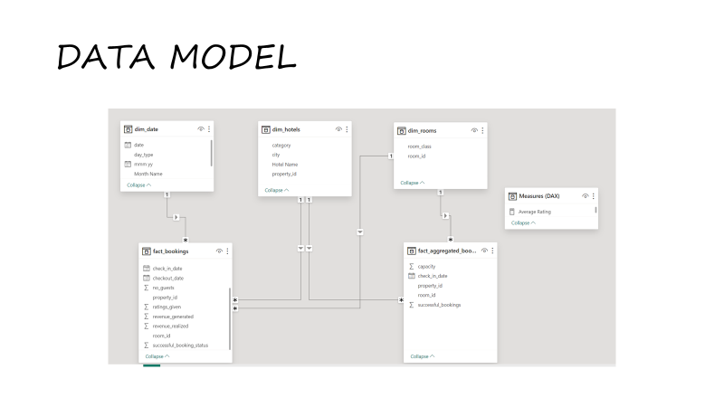
Data Flow Diagram:
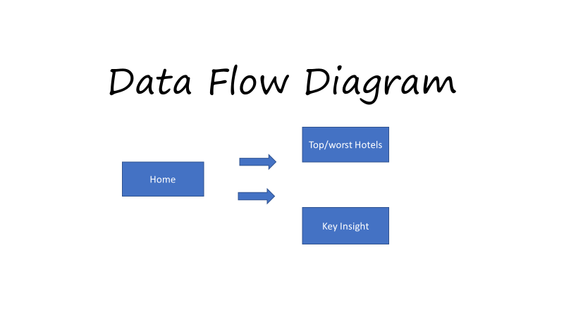

Tool Used : MS Excel (CSV FILE),Power Bi ( reporting tool)

